|  |  |  |
| --- | --- | --- |
| HOW TO | | |
|  |  |  |
| XRPL Asset platform | | |

TABLE DES MATIÈRES

OUR WEBSITE 3

I- Getting Started 3

II- What is the XRP Ledger 3

III- Understanding Real-World Assets 3

STEP BY STEP TUTORIAL 4

I- Create a token 4

II- See my differents assets 7

# OUR WEBSITE

## Getting Started

Our platform allow users to tokenize real-world assets and trade them securely on the XRP Ledger. Below you could find an introduction to the fundamentals concepts and how to begin using our platform.

## What is the XRP Ledger

The XRP Ledger is a decentralized blockchain technology designed for fast and efficient transactions. It enables tokenization of assets, secure transactions, and seamless financial operations with minimal fees. Our platform utilizes XRP Ledger to ensure transparent and immutable records of asset ownership and transactions.

## Understanding Real-World Assets

Real-world assets refer to tangible or intangible assets that exist in the real world, outside the digital world, but can be represented as tokens on a blockchain. These can include but not limited to:

* **Real Estate**: Properties such as homes, commercial buildings or lands.
* **Artwork & Collectibles**: Paintings, sculptures and rare items.
* **Commodities**: Precious metals, energy resources or agricultural products

By tokenizing these assets on the XRP Ledger, users can trade them more efficiently and access a broader market.

# STEP BY STEP TUTORIAL

For the rest of the files, all the red squares on the different pictures will be where you need to click or the place to fill.

## Create a token

This is our home page. To tokenize your first asset, you need to go on the tokenizer page.

**Once on the tokenizer page, you have access to your wallet, if you don’t have one then you can connect yourself to create one.**

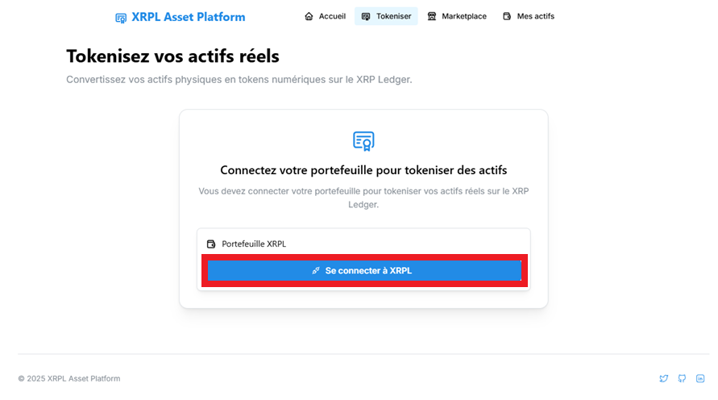

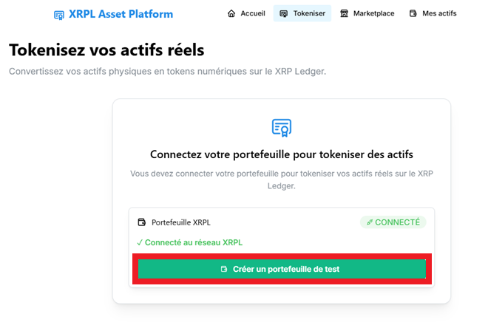

**Now that our wallet is created, you can create your new token:**

**You need to complete the form, we have different asset available, you need to put a name, a value…**

**Once created you can see a message like this with a different token ID. This is your new token !**

## See my differents assets

To see all the different assets that I have we can go on the “Mes actifs” page.

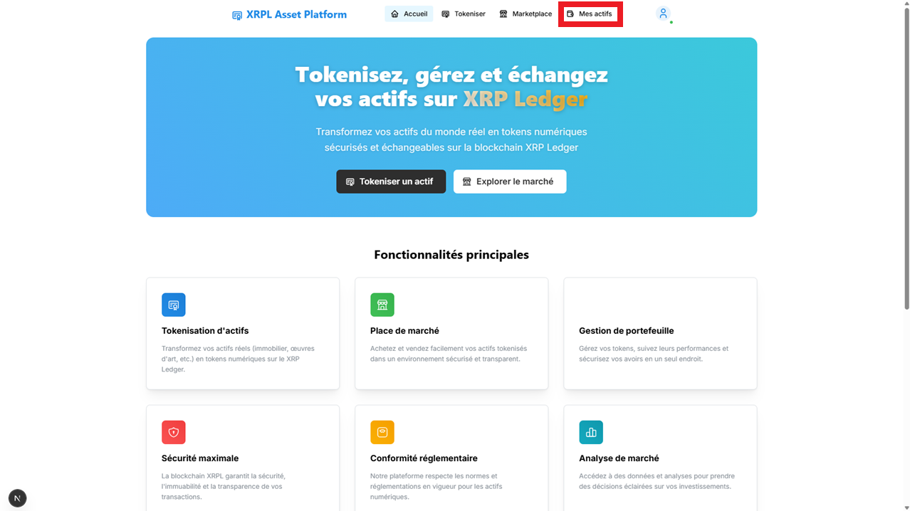

Here you have access to all you assets, created, or bought.

## Sell an asset

For this you need to go on the marketplace page

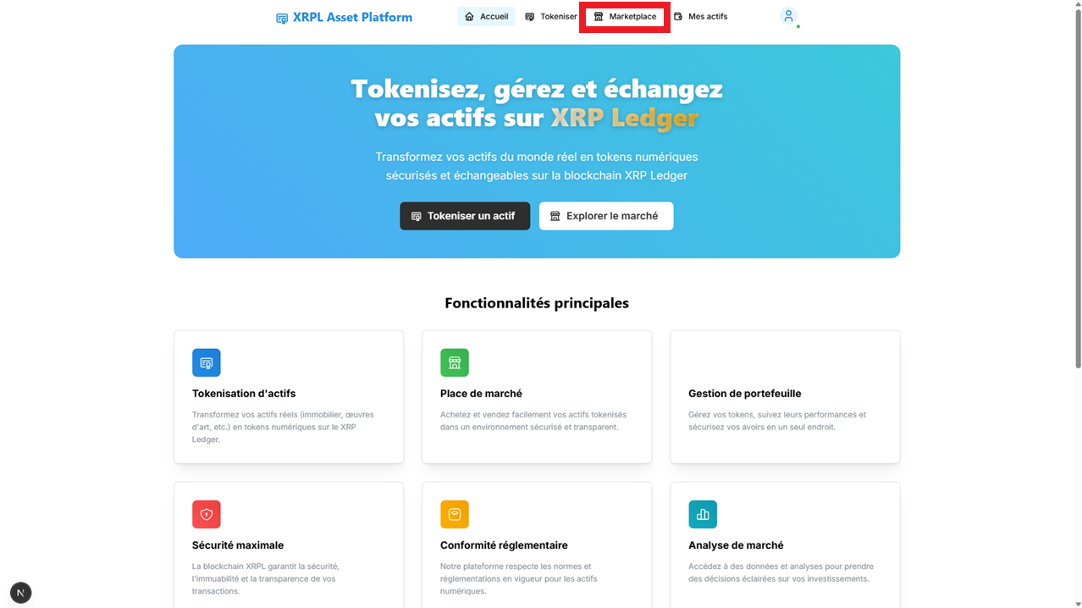

From here you can see all the different assets who are available to buy.

For now, there is no offer, let’s create our own!

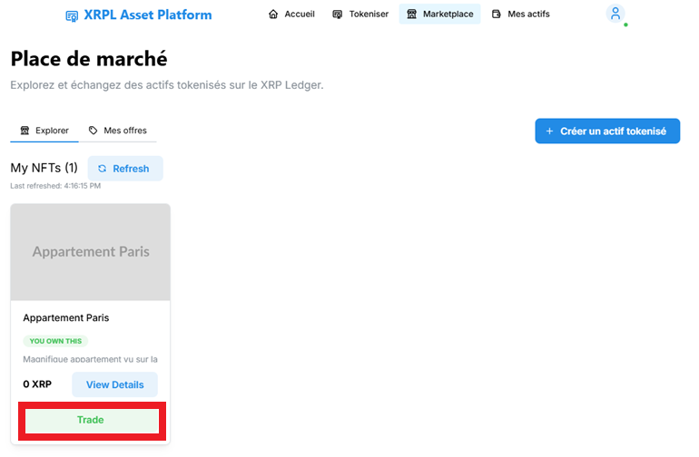

A new window opened once the trade button clicked. You can now fix a price or sell it to a specific user. And even see if somebody makes an offer for it. Une image contenant texte, capture d’écran, logiciel, nombre

Once created you will see the different ID created for this transaction and the new offer you just made appear.

## Buy an asset

Go back to the marketplace page.  
  
From here you will be able to see all the different Asset sell by other user

You want to buy the “Appartement Paris” asset? Click on trade and go into the offers.

If you click on “Accept” you will be able to bought it, then it will appear in your assets !